HANDLE ®
Level I and Level II trainings – open to all
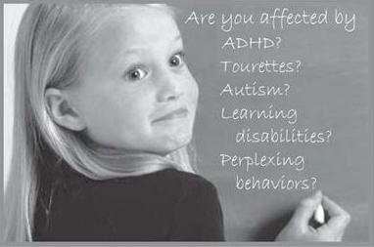

What is HANDLE®
August 4, 2014
12-1 PM and 6 – 7:30 PM – Free presentation
Honest Weight Food Co-op,
Albany, NY

❖

Intensive – Level I & Level II
July 13-14, 2014
Atlas Foundation for Autism, NYC with Elizabeth Frishkoff and
Shifra Leiser, OTD
❖

Level I
August 9, 2014
Mildred Elley College,
School of Massage, Albany, NY
with Elizabeth Frishkoff
❖

Level II
August 16-17, 2014
The Health Center
Main St, Great Barrington, MA
with Elizabeth Frishkoff

Holistic
Approach to
Neuro
Development
and Learning
Efficiency
HANDLE is a unique, gentle, non-drug movement therapy for children and adults. HANDLE was developed by Judith Bluestone, who herself overcame neurological and physiological challenges and became an award winning therapist and educator.

why Judith Bluestone, founder of the HANDLE Institute, proposed that ADD (Attention Deficit Disorder) is a misnomer.

root causes for behavior and learning issues including: hypersensitivities, gastrointestinal, immunological, psychological and neurological complications.

how ADHD, Autism etc. are systems disorders requiring a systems approach to treatment (based on an understanding of the connections and interactions between aspects of the neurological system).

subtle signs of stress and how to adapt to avoid crisis.

selected HANDLE activities that can be immediately applied in classroom, home and clinic settings.

Discover

Explore

Understand

Recognize

Learn

Additional HANDLE workshops:
Level I offers an over-view of the HANDLE paradigm, and Gentle Enhancement®
including instruction in some unique HANDLE activities.
Level II builds upon the Level I with an in-depth look at sensory processing
systems. Students learn more activities and different applications for a variety of
presenting concerns.
Level I and II courses do not qualify an individual to train others in HANDLE
activities.

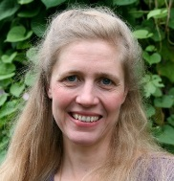

For more information:
413-528-0477 efrish@sover.net

or visit the HANDLE website: www.handle.org

Elizabeth Frishkoff, MSW, Certified HANDLE Instructor and Waldorf graduate, has been working with the HANDLE
approach in clinical, school and home-based settings. From preschool students to nursing home residents, she serves clients with a wide range of life and learning challenges.

For more information on The HANDLE Institute, a training and research organization,
and for links to qualified HANDLE providers worldwide visit: www.handle.org or call 206-909-6028

